Complex Networks
Exercise 2: Community detection algorithms

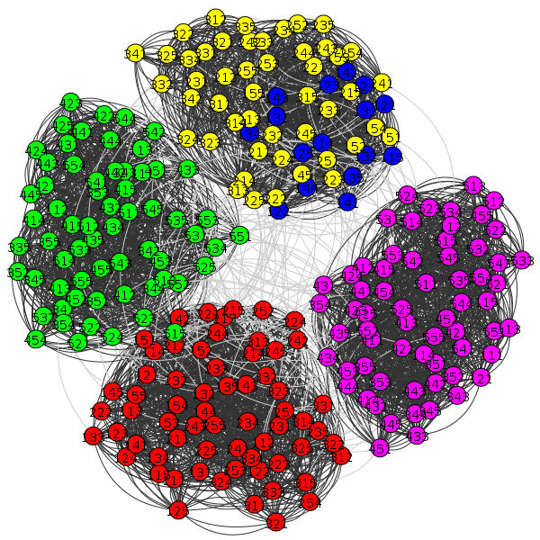

Author: Aleix Solanes
Course: Fall 2015-2016
Subject: Complex Networks
Table of Contents
Objective 3
Algorithms 3
Community multilevel 3
Community fastgreedy 3
Louvain 3
Software 4
Network analysis 5
Model networks 5
256_4_4_2_15_18 5
Community multilevel 6
Community fast-greedy 7
Louvain 8
Radatools 9
Results 10
256_4_4_4_13_18 11
Community multilevel 12
Community fast-greedy 13
Louvain 14
Radatools 15
Results 16
Rb125 17
Community multilevel 18
Community fast-greedy 19
Louvain 20
Radatools 21
Results 22
Real networks 23
Airports_UW 23
Community multilevel 24
Community fast-greed 25
Louvain 26
Radatools 27
Results 28
Cat_cortex_sim 29
Community multilevel 30
Community fast-greed 31
Louvain 32
Radatools 33
Results 34
Dolphins 35
Community multilevel 36
Community fast-greed 37
Louvain 38
Radatools 39
Results 40
Football 41
Community multilevel 42
Community fast-greed 43
Louvain 44
Radatools 45
Results 46
Zachary_unwh 47
Community multilevel 48
Community fast-greed 49
Louvain 50
Radatools 51
Results 52
Toy networks 53
20x2+5x2 53
Community multilevel 54
Community fast-greed 55
Louvain 56
Radatools 57
Results 58
Graph3+1+3 59
Community multilevel 60
Community fast-greed 61
Louvain 62
Radatools 63
Results 64
Graph4+4 65
Community multilevel 66
Community fast-greed 67
Louvain 68
Radatools 69
Results 70
Star 71
Community multilevel 72
Community fast-greed 73
Louvain 74
Radatools 75
Results 76

Objective
Apply at least three different algorithms of community detection to the attached networks. It is not necessary to implement them, you may use any free access programs you like. At least one of the algorithms must be based on the optimization of modularity, and you must use at least two different programs (i.e. do not use all algorithms from the same program).
Some of the provided networks come with a reference partition, obtained from real information of the network. In those cases, you must compare your partitions with the reference ones, using at least the following standard measures: Jaccard Index, Normalized Mutual Information and Normalized Variation of Information. Once again, you don't need to implement them, they can be calculated e.g. using Radatools.

Algorithms

Community multilevel
Community structure based on the multilevel algorithm of Blondel et al.
This is a bottom-up algorithm: initially every vertex belongs to a separate community, and vertices are moved between communities iteratively in a way that maximizes the vertices' local contribution to the overall modularity score. When a consensus is reached (i.e. no single move would increase the modularity score), every community in the original graph is shrank to a single vertex (while keeping the total weight of the adjacent edges) and the process continues on the next level. The algorithm stops when it is not possible to increase the modularity any more after shrinking the communities to vertices.

Community fastgreedy
Community structure based on the greedy optimization of modularity.
This algorithm merges individual nodes into communities in a way that greedily maximizes the modularity score of the graph. It can be proven that if no merge can increase the current modularity score, the algorithm can be stopped since no further increase can be achieved.

Louvain
The method is a greedy optimization method that attempts to optimize the "modularity" of a partition of the network. The optimization is performed in two steps. First, the method looks for "small" communities by optimizing modularity locally. Second, it aggregates nodes belonging to the same community and builds a new network whose nodes are the communities. These steps are repeated iteratively until a maximum of modularity is attained and a hierarchy of communities is produced. Although the exact computational complexity of the method is not known, the method seems to run in time O(n log n) with most of the computational effort spent on the optimization at the first level. Exact modularity optimization is known to be NP-hard.

Software
In order to perform the analysis the software used is the following:
- Python-igraph
- Louvain
- Community
- Networkx
- Radatools

Results

Model
The following table shows the results regarding the given original cluster:

256_4_4_2_15_18_p
Algorithm | Jaccard Index | Normalized Mutual Information (arithmetic) | Normalized Variation of Information
Multilevel | 1 | 1 | 0
Fast-greed | 0.4839 | 0.8697 | 0.1153
Louvain | 1 | 1 | 0

Modularity multilevel : 0.7818
Modularity fast-greed : 0.7656
Modularity louvain : 0.7818
Modularity real : 0.7818

256_4_4_4_13_18_p

Algorithm | Jaccard Index | Normalized Mutual Information  (arithmetic) | Normalized Variation of Information
Multilevel | 0.9048 | 0.9517 | 0.0254
Fast-greed | 1 | 1 | 0
Louvain | 1 | 1 | 0

Modularity multilevel : 0.6974
Modularity fast-greed : 0.6968
Modularity louvain : 0.6968
Modularity real : 0.6968

Rb125
With respect to Rb125-1.clu

Algorithm | Jaccard Index | Normalized Mutual Information  (arithmetic) | Normalized Variation of Information
Multilevel | 0.6167 | 0.8450 | 0.1223
Fast-greed | 0.6167 | 0.8450 | 0.1223
Louvain | 0.5833 | 0.8284 | 0.1381

Modularity multilevel : 0.6169
Modularity fast-greed : 0.6169
Modularity louvain : 0.6087
Modularity real : 0.6006

With respect to Rb125-2.clu

Algorithm | Jaccard Index | Normalized Mutual Information  (arithmetic) | Normalized Variation of Information
Multilevel | 0.2703 | 0.8119 | 0.2111
Fast-greed | 0.2703 | 0.8119 | 0.2111
Louvain | 0.2857 | 0.8284 | 0.1952

Modularity real : 0.5581
With respect to Rb125-3.clu

Algorithm | Jaccard Index | Normalized Mutual Information  (arithmetic) | Normalized Variation of Information
Multilevel | 0.2659 | 0.8089 | 0.2152
Fast-greed | 0.2659 | 0.8089 | 0.2152
Louvain | 0.2811 | 0.8254 | 0.1994

Modularity real : 0.5531

Real

Airports_UW
No real partition to compare
Modularity multilevel : 0.6919
Modularity fast-greed : 0.6625
Modularity louvain : 0.6831
Modularity real : no real partition

Cat_Cortex_Sim

Algorithm | Jaccard Index | Normalized Mutual Information  (arithmetic) | Normalized Variation of Information
Multilevel | 0.5894 | 0.6726 | 0.1981
Fast-greed | 0.5422 | 0.6569 | 0.2056
Louvain | 0.5894 | 0.6726 | 0.1981

Modularity multilevel : 0.2660
Modularity fast-greed : 0.2604
Modularity louvain : 0.2660
Modularity real : 0.2460

Dolphins

Algorithm | Jaccard Index | Normalized Mutual Information  (arithmetic) | Normalized Variation of Information
Multilevel | 0.3631 | 0.5109 | 0.2581
Fast-greed | 0.5041 | 0.5727 | 0.1883
Louvain | 0.3791 | 0.5162 | 0.2526

Modularity multilevel : 0.5185
Modularity fast-greed : 0.4954
Modularity louvain : 0.5188
Modularity real : 0.3735

Football

Algorithm | Jaccard Index | Normalized Mutual Information  (arithmetic) | Normalized Variation of Information
Multilevel | 0.7004 | 0.8903 | 0.1095
Fast-greed | 0.3622 | 0.6977 | 0.2675
Louvain | 0.6959 | 0.8850 | 0.1148

Modularity multilevel : 0.6046
Modularity fast-greed : 0.5497
Modularity louvain : 0.6043
Modularity real : 0.5540

Zachary_unwh

Algorithm | Jaccard Index | Normalized Mutual Information  (arithmetic) | Normalized Variation of Information
Multilevel | 0.4754 | 0.5866 | 0.2359
Fast-greed | 0.6833 | 0.7069 | 0.1509
Louvain | 0.5348 | 0.6873 | 0.1784

Modularity multilevel : 0.4188
Modularity fast-greed : 0.3807
Modularity louvain : 0.4198
Modularity real : 0.3715

Toy

20x2+5x2

Algorithm | Jaccard Index | Normalized Mutual Information  (arithmetic) | Normalized Variation of Information
Multilevel | 0.9412 | 0.9383 | 0.0354
Fast-greed | 0.9412 | 0.9383 | 0.0354
Louvain | 0.9412 | 0.9383 | 0.0354

Modularity multilevel : 0.5426
Modularity fast-greed : 0.5426
Modularity louvain : 0.5426
Modularity real : 0.5416

Graph3+1+3

Algorithm | Jaccard Index | Normalized Mutual Information  (arithmetic) | Normalized Variation of Information
Multilevel | 1 | 1 | 0
Fast-greed | 1 | 1 | 0
Louvain | 1 | 1 | 0

Modularity multilevel : 0.3672
Modularity fast-greed : 0.3672
Modularity louvain : 0.3672
Modularity real : 0.3672

Graph4+4

Algorithm | Jaccard Index | Normalized Mutual Information  (arithmetic) | Normalized Variation of Information
Multilevel | 1 | 1 | 0
Fast-greed | 1 | 1 | 0
Louvain | 1 | 1 | 0

Modularity multilevel : 0.4231
Modularity fast-greed : 0.4231
Modularity louvain : 0.4231
Modularity real : 0.4231

Star

Algorithm | Jaccard Index | Normalized Mutual Information  (arithmetic) | Normalized Variation of Information
Multilevel | 1 | 1 | 0
Fast-greed | 1 | 1 | 0
Louvain | 1 | 1 | 0

Modularity multilevel : 0.0
Modularity fast-greed : 0.0
Modularity louvain : 0.0
Modularity real : 0.0

Network analysis

Model networks

256_4_4_2_15_18
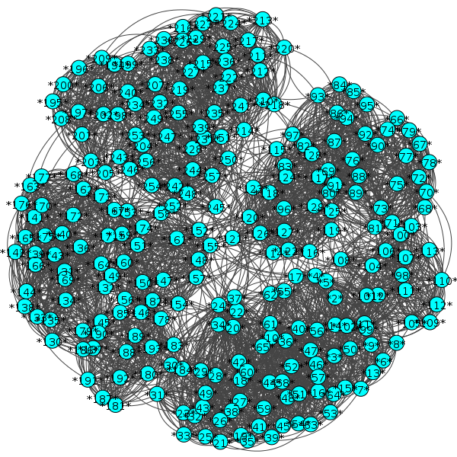

Community multilevel
Clustering with 256 elements and 16 clusters
Number of communities: 16
Modularity: 0.781804212508
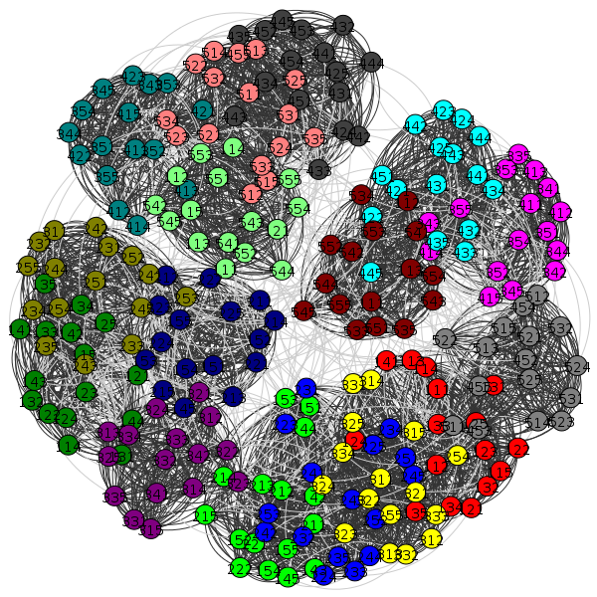

Community fast-greedy
Clustering with 256 elements and 9 clusters
Number of communities: 9
Modularity: 0.765659796917
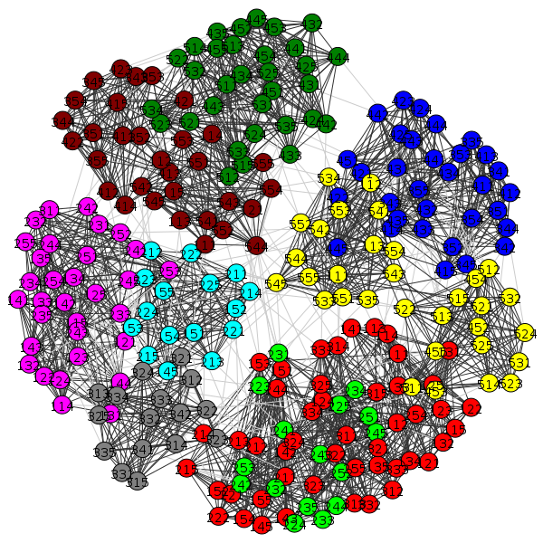

Louvain
Clustering with 256 elements and 15 clusters
Number of communities: 15
Modularity: 0.780765357152
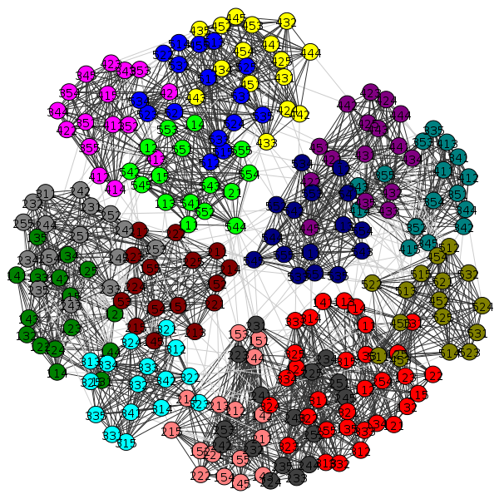

Radatools
---------
Parameters: WN erfrtrfr 5
Q = 0.781804
---
Number of elements: 256
Number of lists: 16

16: 209 210 211 212 213 214 215 216 217 218 219 220 221 222 223 224
16: 49 50 51 52 53 54 55 56 57 58 59 60 61 62 63 64
16: 113 114 115 116 117 118 119 120 121 122 123 124 125 126 127 128
16: 65 66 67 68 69 70 71 72 73 74 75 76 77 78 79 80
16: 145 146 147 148 149 150 151 152 153 154 155 156 157 158 159 160
16: 225 226 227 228 229 230 231 232 233 234 235 236 237 238 239 240
16: 241 242 243 244 245 246 247 248 249 250 251 252 253 254 255 256
16: 81 82 83 84 85 86 87 88 89 90 91 92 93 94 95 96
16: 161 162 163 164 165 166 167 168 169 170 171 172 173 174 175 176
16: 177 178 179 180 181 182 183 184 185 186 187 188 189 190 191 192
16: 17 18 19 20 21 22 23 24 25 26 27 28 29 30 31 32
16: 1 2 3 4 5 6 7 8 9 10 11 12 13 14 15 16
16: 193 194 195 196 197 198 199 200 201 202 203 204 205 206 207 208
16: 129 130 131 132 133 134 135 136 137 138 139 140 141 142 143 144
16: 33 34 35 36 37 38 39 40 41 42 43 44 45 46 47 48
16: 97 98 99 100 101 102 103 104 105 106 107 108 109 110 111 112

Results

256_4_4_4_13_18
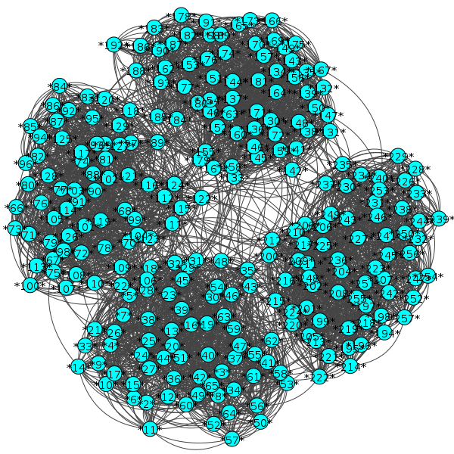

Community multilevel
Clustering with 256 elements and 5 clusters
Number of communities: 5
Modularity: 0.69741889026

Community fast-greedy
Clustering with 256 elements and 4 clusters
Number of communities: 4
Modularity: 0.696773338485
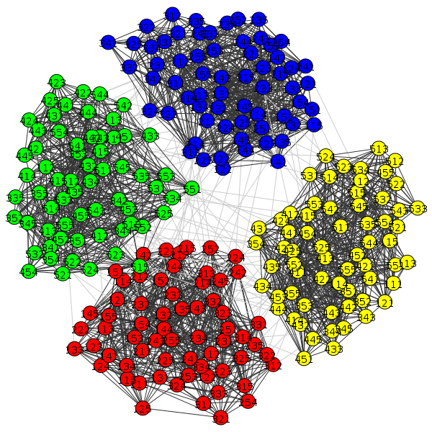

Louvain
Clustering with 256 elements and 5 clusters
Number of communities: 5
Modularity: 0.69741889026
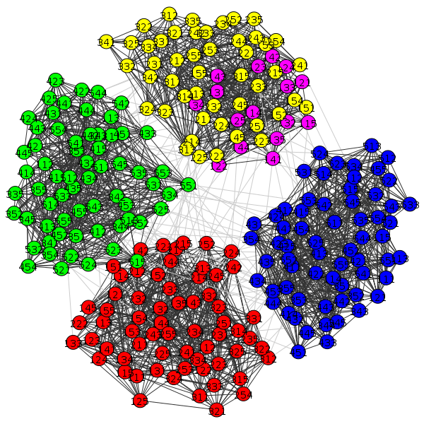

Radatools
---------
Parameters: WN erfrtrfr 5
Q = 0.697419
---
Number of elements: 256
Number of lists: 5

64: 65 66 67 68 69 70 71 72 73 74 75 76 77 78 79 80 81 82 83 84 85 86 87 88 89 90 91 92 93 94 95 96 97 98 99 100 101 102 103 104 105 106 107 108 109 110 111 112 113 114 115 116 117 118 119 120 121 122 123 124 125 126 127 128
64: 193 194 195 196 197 198 199 200 201 202 203 204 205 206 207 208 209 210 211 212 213 214 215 216 217 218 219 220 221 222 223 224 225 226 227 228 229 230 231 232 233 234 235 236 237 238 239 240 241 242 243 244 245 246 247 248 249 250 251 252 253 254 255 256
64: 1 2 3 4 5 6 7 8 9 10 11 12 13 14 15 16 17 18 19 20 21 22 23 24 25 26 27 28 29 30 31 32 33 34 35 36 37 38 39 40 41 42 43 44 45 46 47 48 49 50 51 52 53 54 55 56 57 58 59 60 61 62 63 64
48: 145 146 147 148 149 150 151 152 153 154 155 156 157 158 159 160 161 162 163 164 165 166 167 168 169 170 171 172 173 174 175 176 177 178 179 180 181 182 183 184 185 186 187 188 189 190 191 192
16: 129 130 131 132 133 134 135 136 137 138 139 140 141 142 143 144

Results

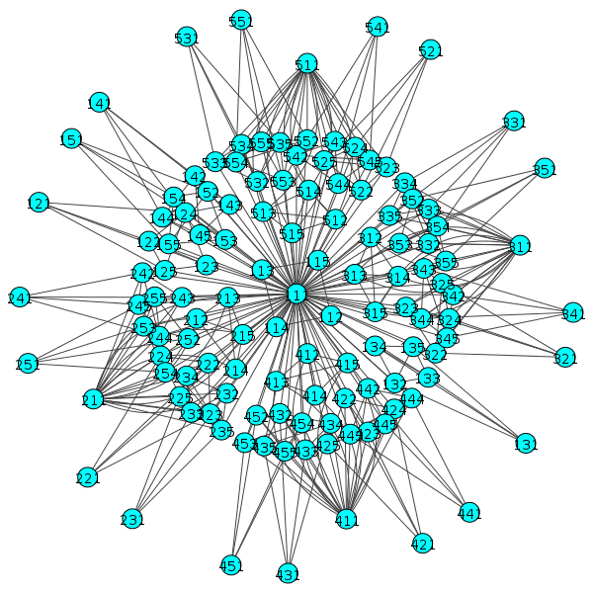
Rb125

Community multilevel
Clustering with 125 elements and 11 clusters
Number of communities: 11
Modularity: 0.616897000154
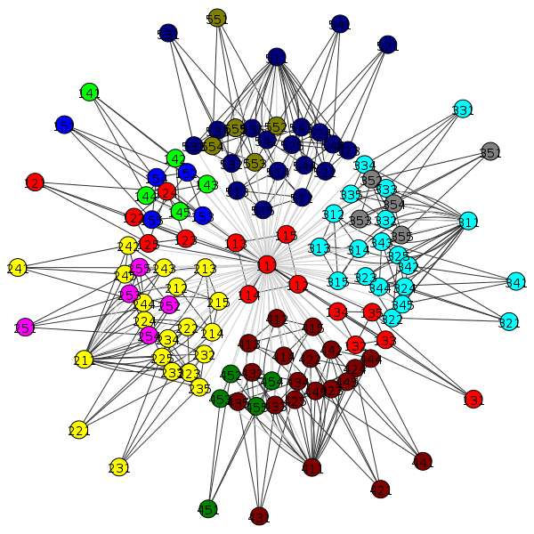

Community fast-greedy
Clustering with 125 elements and 11 clusters
Number of communities: 11
Modularity: 0.616897000154
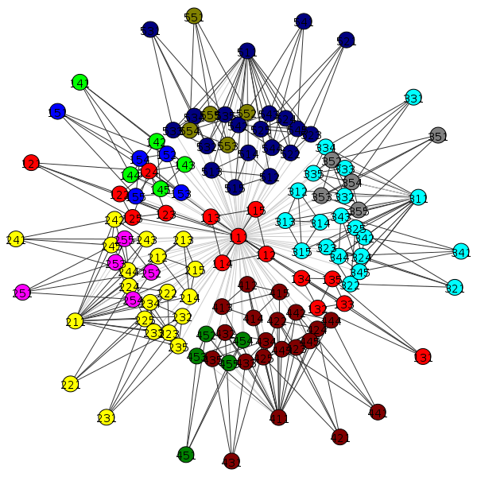

Louvain
Clustering with 125 elements and 12 clusters
Number of communities = 12
Modularity: 0.608732897085

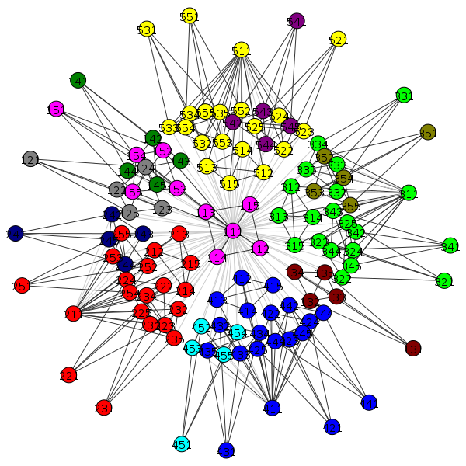

Radatools
---------
Parameters: WN erfrtrfr 5
Q = 0.608733
---
Number of elements: 125
Number of lists: 12

20: 26 27 28 29 30 36 37 38 39 40 41 42 43 44 45 46 47 48 49 50
20: 101 102 103 104 105 111 112 113 114 115 116 117 118 119 120 121 122 123 124 125
20: 76 77 78 79 80 81 82 83 84 85 86 87 88 89 90 91 92 93 94 95
20: 51 52 53 54 55 56 57 58 59 60 61 62 63 64 65 66 67 68 69 70
10: 1 2 3 4 5 21 22 23 24 25
5: 11 12 13 14 15
5: 16 17 18 19 20
5: 96 97 98 99 100
5: 31 32 33 34 35
5: 106 107 108 109 110
5: 6 7 8 9 10
5: 71 72 73 74 75

Results

Real networks

Airports_UW
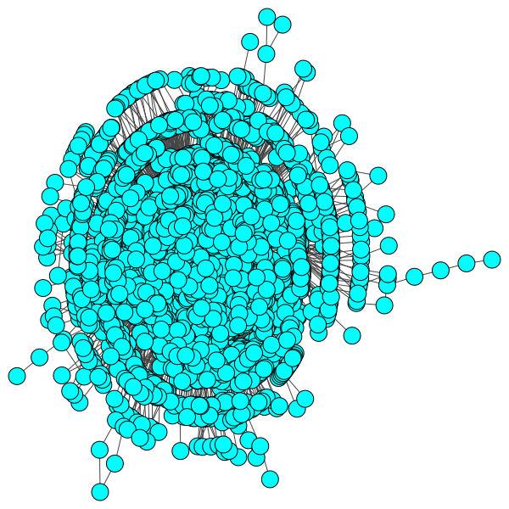

Community multilevel
Clustering with 3618 elements and 35 clusters
Number of communities: 35
Modularity: 0.691904965737
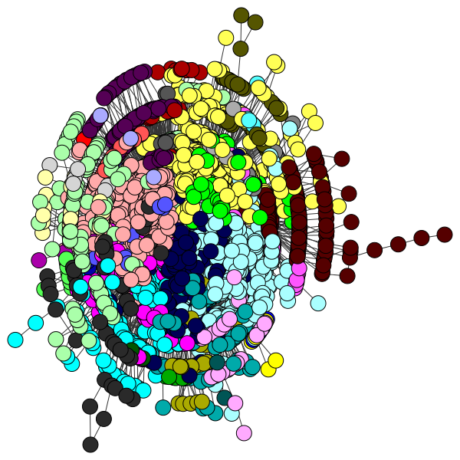

Community fast-greed
Clustering with 3618 elements and 42 clusters
Number of communities: 42
Modularity: 0.662490246563

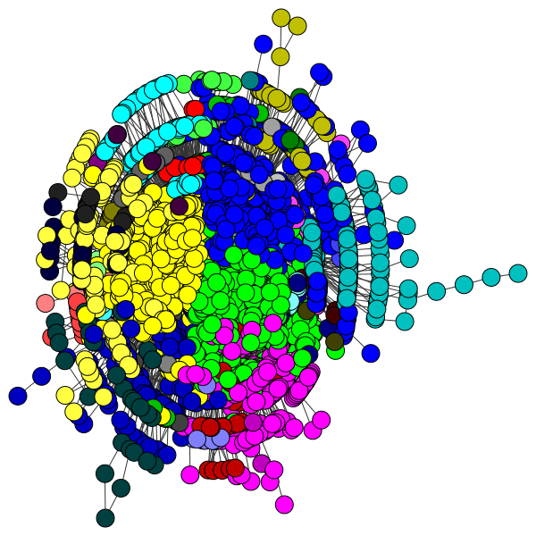

Louvain
Clustering with 3618 elements and 30 clusters
Number of communities: 30
Modularity: 0.705925137144

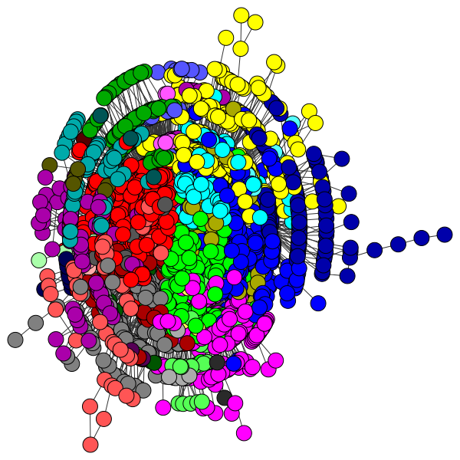

Radatools
---------
Parameters: WN erfrtrfr 5
Q = 0.649223
---
Number of elements: 3618
Number of lists: 23

The membership is not included due to being a really long text (3618 values distributed in 23 clusters)

Results

Cat_cortex_sim
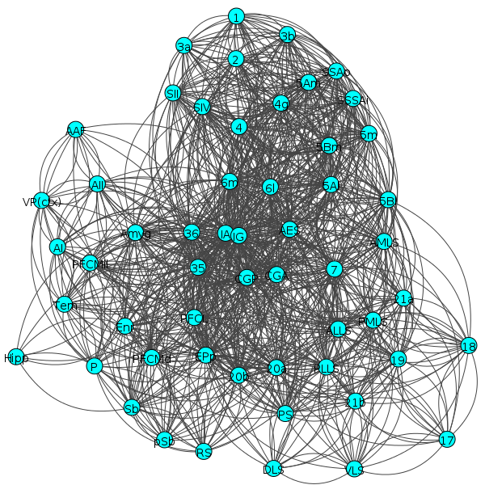

Community multilevel
Clustering with 55 elements and 3 clusters
[0] 0, 1, 2, 3, 4, 5, 6, 7, 8, 9, 10, 11, 13, 15, 36
[1] 14, 23, 24, 25, 26, 27, 28, 29, 30, 31, 32, 33, 34, 35, 37, 38, 39, 44
[2] 12, 16, 17, 18, 19, 20, 21, 22, 40, 41, 42, 43, 45, 46, 47, 48, 49, 50,
51, 52, 53, 54
Membership:
[0, 0, 0, 0, 0, 0, 0, 0, 0, 0, 0, 0, 2, 0, 1, 0, 2, 2, 2, 2, 2, 2, 2, 1, 1, 1, 1, 1, 1, 1, 1, 1, 1, 1, 1, 1, 0, 1, 1, 1, 2, 2, 2, 2, 1, 2, 2, 2, 2, 2, 2, 2, 2, 2, 2]
Number of communities: 3
Modularity: 0.266097341683

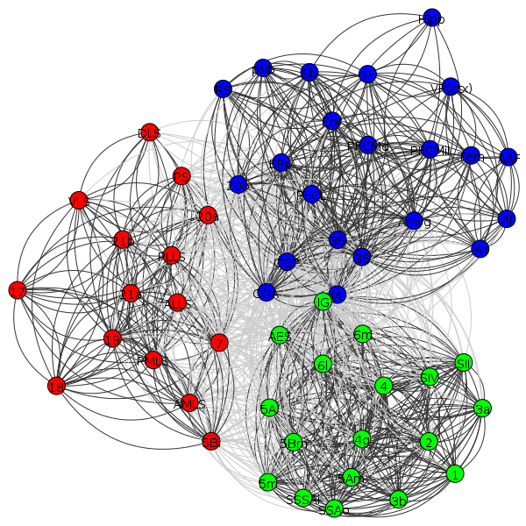

Community fast-greed
Optimal number of clusters: 3
Clustering with 55 elements and 3 clusters
[0] 0, 1, 2, 3, 4, 5, 6, 7, 8, 9, 10, 13, 36
[1] 11, 12, 15, 16, 17, 18, 19, 20, 21, 22, 40, 41, 42, 43, 44, 45, 46, 47,
48, 49, 50, 51, 52, 53, 54
[2] 14, 23, 24, 25, 26, 27, 28, 29, 30, 31, 32, 33, 34, 35, 37, 38, 39
Membership:
[0, 0, 0, 0, 0, 0, 0, 0, 0, 0, 0, 1, 1, 0, 2, 1, 1, 1, 1, 1, 1, 1, 1, 2, 2, 2, 2, 2, 2, 2, 2, 2, 2, 2, 2, 2, 0, 2, 2, 2, 1, 1, 1, 1, 1, 1, 1, 1, 1, 1, 1, 1, 1, 1, 1]
Number of communities: 3
Modularity: 0.260435528897

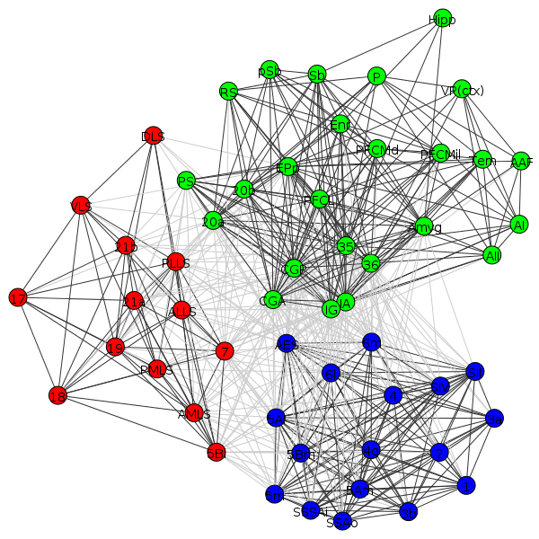

Louvain
Clustering with 55 elements and 3 clusters
[0] 12, 16, 17, 18, 19, 20, 21, 22, 40, 41, 42, 43, 45, 46, 47, 48, 49, 50,
51, 52, 53, 54
[1] 14, 23, 24, 25, 26, 27, 28, 29, 30, 31, 32, 33, 34, 35, 37, 38, 39, 44
[2] 0, 1, 2, 3, 4, 5, 6, 7, 8, 9, 10, 11, 13, 15, 36
Quality: 258.919165159
Modularity: 0.266097341683
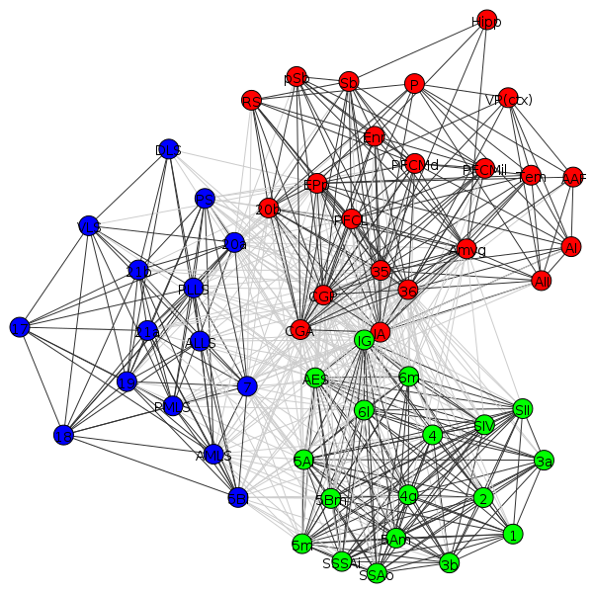

Radatools
---------
Parameters: WN erfrtrfr 5
Q = 0.370924
---
Number of elements: 55
Number of lists: 3

24: 13 16 17 18 19 20 21 22 23 41 42 43 44 45 46 47 48 49 50 51 52 53 54 55
19: 14 15 24 25 26 27 28 29 30 31 32 33 34 35 36 37 38 39 40
12: 1 2 3 4 5 6 7 8 9 10 11 12

Results

Dolphins
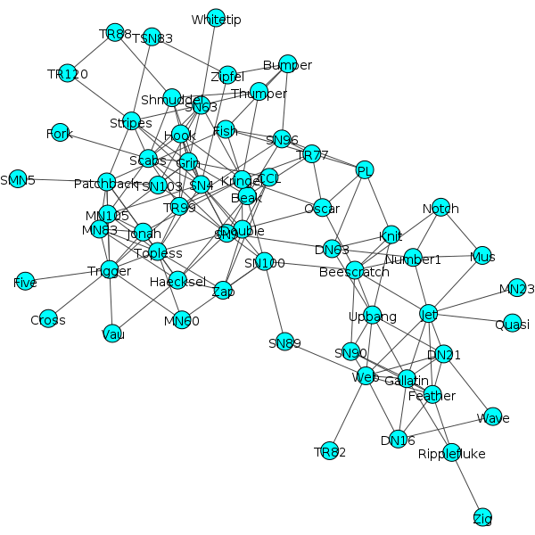

Community multilevel
Clustering with 62 elements and 5 clusters
[0] 0, 2, 10, 42, 47, 53, 61
[1] 1, 7, 19, 25, 26, 27, 28, 30
[2] 12, 14, 16, 20, 33, 34, 36, 37, 38, 39, 40, 43, 44, 46, 49, 50, 52, 58
[3] 5, 6, 9, 13, 17, 22, 31, 32, 41, 48, 54, 56, 57, 60
[4] 3, 4, 8, 11, 15, 18, 21, 23, 24, 29, 35, 45, 51, 55, 59
Membership:
[0, 1, 0, 4, 4, 3, 3, 1, 4, 3, 0, 4, 2, 3, 2, 4, 2, 3, 4, 1, 2, 4, 3, 4, 4, 1, 1, 1, 1, 4, 1, 3, 3, 2, 2, 4, 2, 2, 2, 2, 2, 3, 0, 2, 2, 4, 2, 0, 3, 2, 2, 4, 2, 0, 3, 4, 3, 3, 2, 4, 3, 0]
Number of communities: 5
Modularity: 0.518531703651
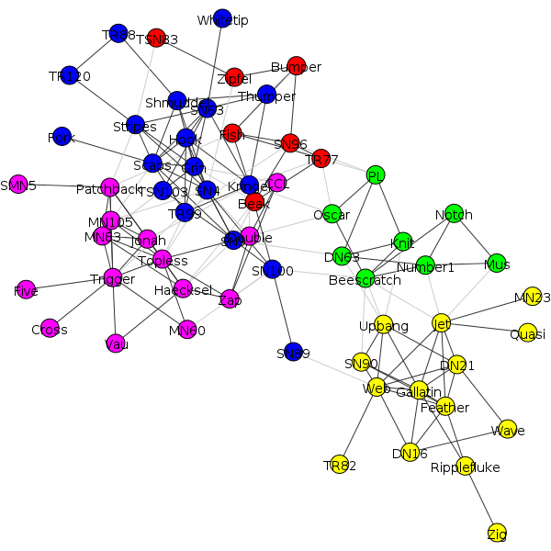

Community fast-greed
Optimal number of clusters: 4
Clustering with 62 elements and 4 clusters
[0] 0, 2, 10, 12, 14, 16, 20, 33, 34, 37, 38, 40, 42, 43, 44, 46, 47, 49, 50,
52, 53, 58, 61
[1] 1, 5, 6, 7, 9, 13, 17, 19, 22, 25, 26, 27, 28, 30, 31, 32, 41, 48, 54, 56,
57, 60
[2] 3, 4, 8, 11, 15, 18, 21, 23, 24, 29, 35, 45, 51, 55, 59
[3] 36, 39
Membership:
[0, 1, 0, 2, 2, 1, 1, 1, 2, 1, 0, 2, 0, 1, 0, 2, 0, 1, 2, 1, 0, 2, 1, 2, 2, 1, 1, 1, 1, 2, 1, 1, 1, 0, 0, 2, 3, 0, 0, 3, 0, 1, 0, 0, 0, 2, 0, 0, 1, 0, 0, 2, 0, 0, 1, 2, 1, 1, 0, 2, 1, 0]
Number of communities: 4
Modularity: 0.495490684704
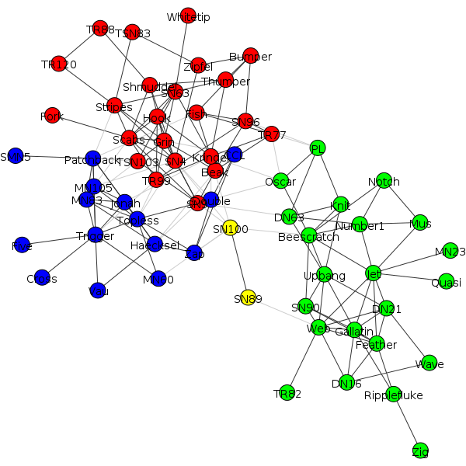

Louvain
Clustering with 62 elements and 5 clusters
[0] 1, 5, 6, 9, 13, 17, 22, 25, 26, 27, 31, 32, 39, 41, 48, 54, 56, 57, 60
[1] 12, 14, 16, 20, 33, 34, 36, 37, 38, 40, 43, 44, 46, 49, 50, 52, 53, 58, 61
[2] 4, 11, 15, 18, 21, 23, 24, 29, 35, 45, 51, 55
[3] 0, 2, 7, 10, 19, 30, 42, 47
[4] 3, 8, 28, 59
Quality: 153.224486471
Modularity: 0.51766148491
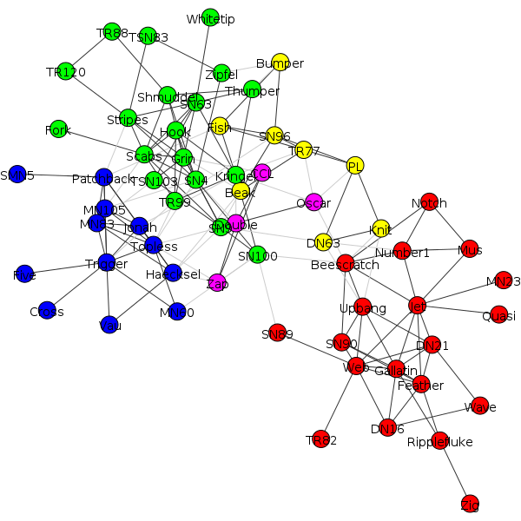

Radatools
---------
Parameters: WN erfrtrfr 5
Q = 0.526799
---
Number of elements: 62
Number of lists: 4

21: 2 6 7 8 10 14 18 20 23 26 27 28 32 33 40 42 49 55 57 58 61
17: 13 15 17 21 34 35 37 38 39 41 44 45 47 50 51 53 59
15: 4 5 9 12 16 19 22 24 25 30 36 46 52 56 60
9: 1 3 11 29 31 43 48 54 62

Results

Football
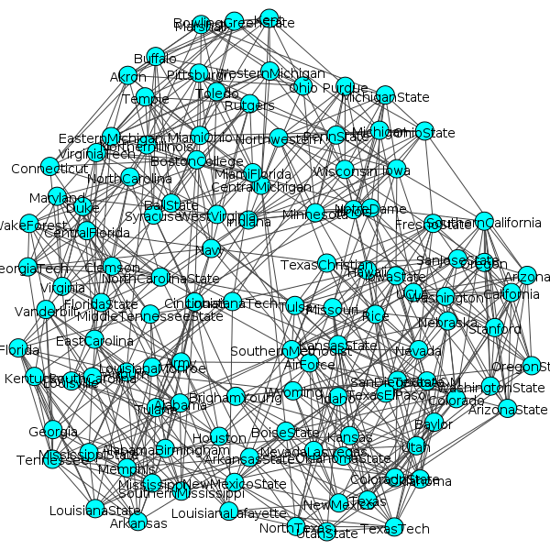

Community multilevel
Clustering with 115 elements and 10 clusters
[ 0] 3, 5, 10, 40, 52, 72, 74, 81, 84, 98, 102, 107
[ 1] 2, 6, 13, 15, 32, 39, 47, 60, 64, 100, 106
[ 2] 1, 25, 33, 37, 45, 89, 103, 105, 109
[ 3] 12, 14, 18, 26, 31, 34, 36, 38, 42, 43, 54, 61, 71, 85, 99
[ 4] 46, 49, 53, 67, 73, 83, 88, 110, 114
[ 5] 0, 4, 9, 11, 16, 23, 24, 28, 41, 50, 69, 90, 93, 104
[ 6] 19, 29, 30, 35, 55, 79, 80, 82, 94, 101
[ 7] 17, 20, 27, 56, 58, 59, 62, 63, 65, 70, 76, 87, 95, 96, 97, 113
[ 8] 44, 48, 57, 66, 75, 86, 91, 92, 112
[ 9] 7, 8, 21, 22, 51, 68, 77, 78, 108, 111
Membership:
[5, 2, 1, 0, 5, 0, 1, 9, 9, 5, 0, 5, 3, 1, 3, 1, 5, 7, 3, 6, 7, 9, 9, 5, 5, 2, 3, 7, 5, 6, 6, 3, 1, 2, 3, 6, 3, 2, 3, 1, 0, 5, 3, 3, 8, 2, 4, 1, 8, 4, 5, 9, 0, 4, 3, 6, 7, 8, 7, 7, 1, 3, 7, 7, 1, 7, 8, 4, 9, 5, 7, 3, 0, 4, 0, 8, 7, 9, 9, 6, 6, 0, 6, 4, 0, 3, 8, 7, 4, 2, 5, 8, 8, 5, 6, 7, 7, 7, 0, 3, 1, 6, 0, 2, 5, 2, 1, 0, 9, 2, 4, 9, 8, 7, 4]
Number of communities: 10
Modularity: 0.604569562683
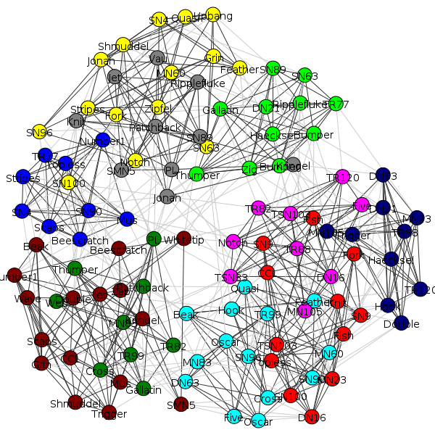

Community fast-greed

Optimal number of clusters: 6
Community:
Clustering with 115 elements and 6 clusters
[0] 0, 1, 19, 25, 29, 30, 33, 35, 37, 45, 55, 79, 80, 82, 89, 93, 94, 101,
103, 105, 109
[1] 2, 3, 4, 5, 10, 11, 24, 28, 40, 50, 52, 69, 72, 74, 81, 83, 84, 90, 98,
102, 107
[2] 6, 13, 15, 32, 39, 47, 60, 64, 100, 106
[3] 7, 8, 9, 16, 21, 22, 23, 41, 46, 49, 51, 53, 67, 68, 73, 77, 78, 88, 104,
108, 110, 111, 114
[4] 12, 14, 18, 26, 31, 34, 38, 43, 54, 61, 71, 85, 99
[5] 17, 20, 27, 36, 42, 44, 48, 56, 57, 58, 59, 62, 63, 65, 66, 70, 75, 76,
86, 87, 91, 92, 95, 96, 97, 112, 113
Membership:
[0, 0, 1, 1, 1, 1, 2, 3, 3, 3, 1, 1, 4, 2, 4, 2, 3, 5, 4, 0, 5, 3, 3, 3, 1, 0, 4, 5, 1, 0, 0, 4, 2, 0, 4, 0, 5, 0, 4, 2, 1, 3, 5, 4, 5, 0, 3, 2, 5, 3, 1, 3, 1, 3, 4, 0, 5, 5, 5, 5, 2, 4, 5, 5, 2, 5, 5, 3, 3, 1, 5, 4, 1, 3, 1, 5, 5, 3, 3, 0, 0, 1, 0, 1, 1, 4, 5, 5, 3, 0, 1, 5, 5, 0, 0, 5, 5, 5, 1, 4, 2, 0, 1, 0, 3, 0, 2, 1, 3, 0, 3, 3, 5, 5, 3]
Number of communities: 6
Modularity: 0.549740665143
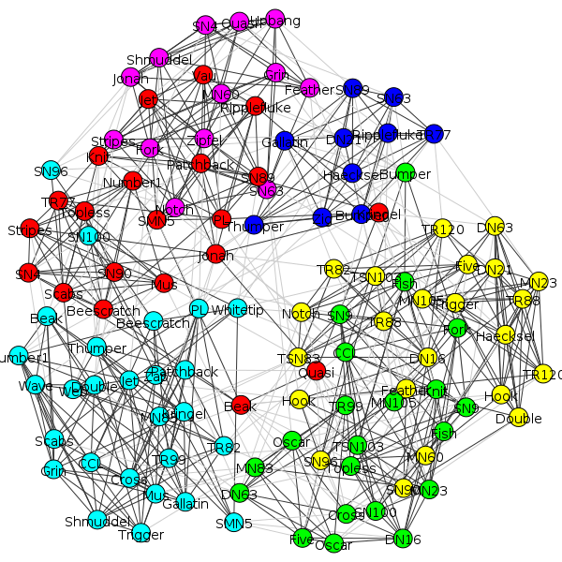

Louvain
Clustering with 115 elements and 9 clusters
[0] 0, 4, 7, 8, 9, 11, 16, 21, 22, 23, 24, 28, 41, 50, 51, 68, 69, 77, 78, 90,
93, 104, 108, 111
[1] 17, 20, 27, 36, 56, 58, 59, 62, 63, 65, 70, 76, 87, 95, 96, 97, 113
[2] 12, 14, 18, 26, 31, 34, 38, 42, 43, 54, 61, 71, 85, 99
[3] 3, 5, 10, 40, 52, 72, 74, 81, 84, 98, 102, 107
[4] 2, 6, 13, 15, 32, 39, 47, 60, 64, 100, 106
[5] 19, 29, 30, 35, 55, 79, 80, 82, 94, 101
[6] 1, 25, 33, 37, 45, 89, 103, 105, 109
[7] 46, 49, 53, 67, 73, 83, 88, 110, 114
[8] 44, 48, 57, 66, 75, 86, 91, 92, 112
Quality: 1301.1979985
Modularity: 0.604183687319
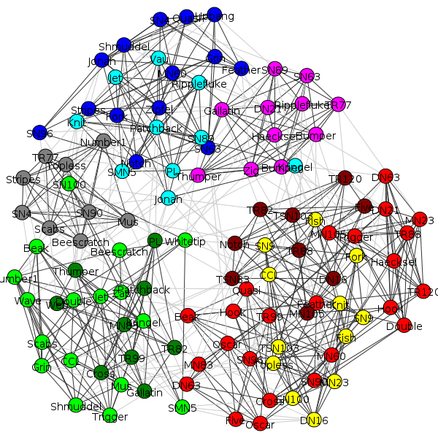

Radatools
---------
Parameters: WN erfrtrfr 5
Q = 0.604429
---
Number of elements: 115
Number of lists: 10

15: 13 15 19 27 32 35 37 39 43 44 55 62 72 86 100
14: 1 5 10 12 17 24 25 29 42 51 70 91 94 105
13: 45 49 58 59 60 64 67 76 87 92 93 98 113
12: 18 21 28 57 63 66 71 77 88 96 97 114
12: 4 6 11 41 53 73 75 82 85 99 103 108
11: 3 7 14 16 33 40 48 61 65 101 107
10: 8 9 22 23 52 69 78 79 109 112
10: 20 30 31 36 56 80 81 83 95 102
9: 47 50 54 68 74 84 89 111 115
9: 2 26 34 38 46 90 104 106 110

Results

Zachary_unwh
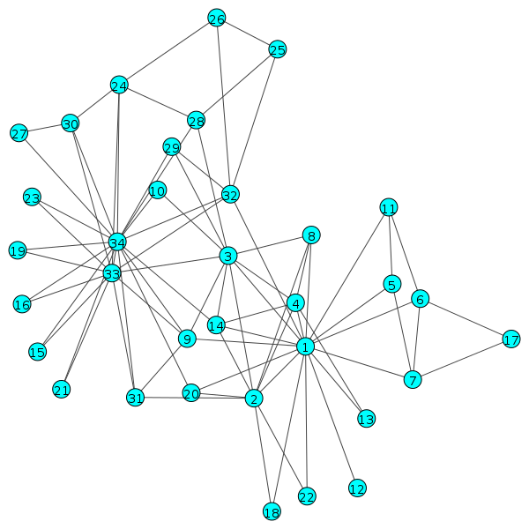

Community multilevel
Clustering with 34 elements and 4 clusters
[0] 4, 5, 6, 10, 16
[1] 0, 1, 2, 3, 7, 9, 11, 12, 13, 17, 19, 21
[2] 23, 24, 25, 27, 28, 31
[3] 8, 14, 15, 18, 20, 22, 26, 29, 30, 32, 33
Membership:
[1, 1, 1, 1, 0, 0, 0, 1, 3, 1, 0, 1, 1, 1, 3, 3, 0, 1, 3, 1, 3, 1, 3, 2, 2, 2, 3, 2, 2, 3, 3, 2, 3, 3]
Number of communities: 4
Modularity: 0.418803418803
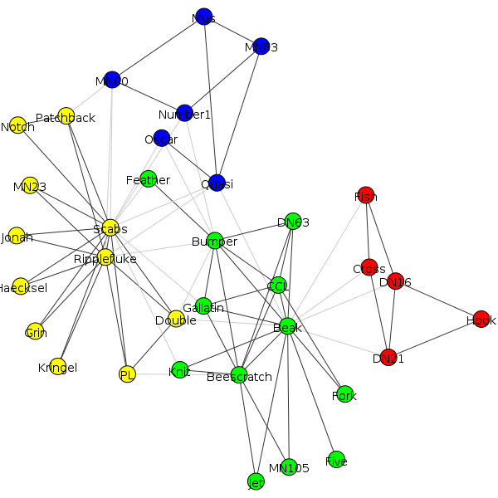

Community fast-greed
Optimal number of clusters: 3
Community:
Clustering with 34 elements and 3 clusters
[0] 0, 4, 5, 6, 10, 11, 16, 19
[1] 1, 2, 3, 7, 9, 12, 13, 17, 21
[2] 8, 14, 15, 18, 20, 22, 23, 24, 25, 26, 27, 28, 29, 30, 31, 32, 33
Membership:
[0, 1, 1, 1, 0, 0, 0, 1, 2, 1, 0, 0, 1, 1, 2, 2, 0, 1, 2, 0, 2, 1, 2, 2, 2, 2, 2, 2, 2, 2, 2, 2, 2, 2]
Number of communities: 3
Modularity: 0.38067061144
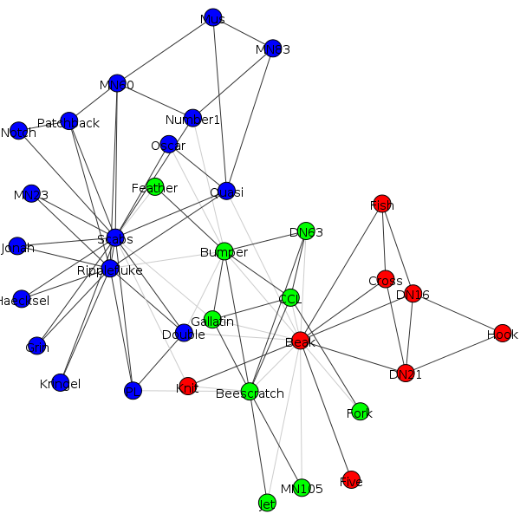

Louvain
Clustering with 34 elements and 4 clusters
[0] 0, 1, 2, 3, 7, 9, 11, 12, 13, 17, 19, 21
[1] 8, 14, 15, 18, 20, 22, 26, 29, 30, 32, 33
[2] 23, 24, 25, 27, 28, 31
[3] 4, 5, 6, 10, 16
Quality: 58.7562119161
Modularity: 0.418803418803
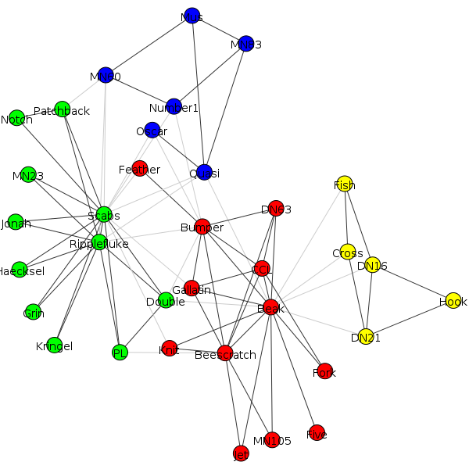

Radatools
---------
Parameters: WN erfrtrfr 5
Q = 0.419790
---
Number of elements: 34
Number of lists: 4

12: 9 10 15 16 19 21 23 27 30 31 33 34
11: 1 2 3 4 8 12 13 14 18 20 22
6: 24 25 26 28 29 32
5: 5 6 7 11 17

Results

Toy networks

20x2+5x2
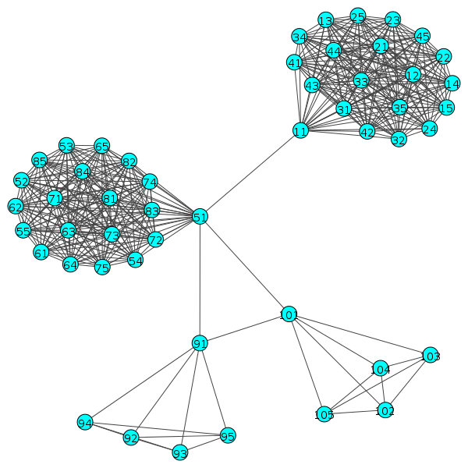

Community multilevel
Clustering with 50 elements and 3 clusters
[0] 0, 1, 2, 3, 4, 5, 6, 7, 8, 9, 10, 11, 12, 13, 14, 15, 16, 17, 18, 19
[1] 20, 21, 22, 23, 24, 25, 26, 27, 28, 29, 30, 31, 32, 33, 34, 35, 36, 37,
38, 39
[2] 40, 41, 42, 43, 44, 45, 46, 47, 48, 49
Membership:
[0, 0, 0, 0, 0, 0, 0, 0, 0, 0, 0, 0, 0, 0, 0, 0, 0, 0, 0, 0, 1, 1, 1, 1, 1, 1, 1, 1, 1, 1, 1, 1, 1, 1, 1, 1, 1, 1, 1, 1, 2, 2, 2, 2, 2, 2, 2, 2, 2, 2]
Number of communities: 3
Modularity: 0.542578546221
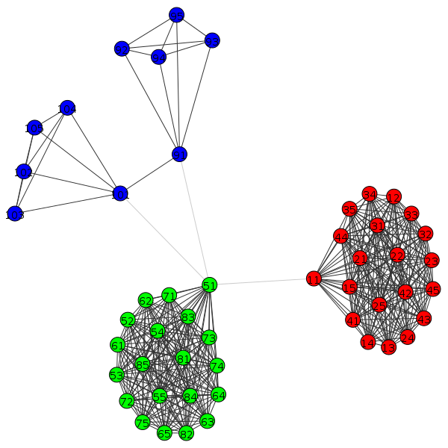

Community fast-greed
Optimal number of clusters: 3
Community:
Clustering with 50 elements and 3 clusters
[0] 0, 1, 2, 3, 4, 5, 6, 7, 8, 9, 10, 11, 12, 13, 14, 15, 16, 17, 18, 19
[1] 20, 21, 22, 23, 24, 25, 26, 27, 28, 29, 30, 31, 32, 33, 34, 35, 36, 37,
38, 39
[2] 40, 41, 42, 43, 44, 45, 46, 47, 48, 49
Membership:
[0, 0, 0, 0, 0, 0, 0, 0, 0, 0, 0, 0, 0, 0, 0, 0, 0, 0, 0, 0, 1, 1, 1, 1, 1, 1, 1, 1, 1, 1, 1, 1, 1, 1, 1, 1, 1, 1, 1, 1, 2, 2, 2, 2, 2, 2, 2, 2, 2, 2]
Number of communities: 3
Modularity: 0.542578546221

Louvain
Clustering with 50 elements and 3 clusters
[0] 0, 1, 2, 3, 4, 5, 6, 7, 8, 9, 10, 11, 12, 13, 14, 15, 16, 17, 18, 19
[1] 20, 21, 22, 23, 24, 25, 26, 27, 28, 29, 30, 31, 32, 33, 34, 35, 36, 37,
38, 39
[2] 40, 41, 42, 43, 44, 45, 46, 47, 48, 49
Quality: 846.668765315
Modularity: 0.542578546221

Radatools
---------
Parameters: WN erfrtrfr 5
Q = 0.542579
---
Number of elements: 50
Number of lists: 3

20: 1 2 3 4 5 6 7 8 9 10 11 12 13 14 15 16 17 18 19 20
20: 21 22 23 24 25 26 27 28 29 30 31 32 33 34 35 36 37 38 39 40
10: 41 42 43 44 45 46 47 48 49 50

Results

Graph3+1+3
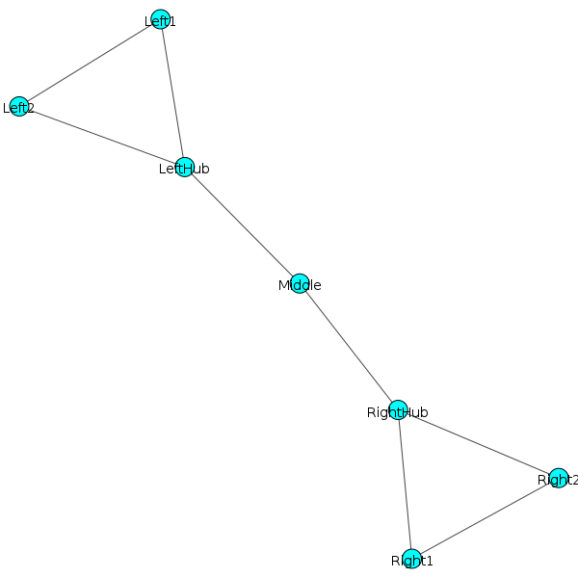

Community multilevel
Clustering with 7 elements and 2 clusters
[0] 0, 1, 2, 3
[1] 4, 5, 6
Membership:
[0, 0, 0, 0, 1, 1, 1]
Number of communities: 2
Modularity: 0.3671875
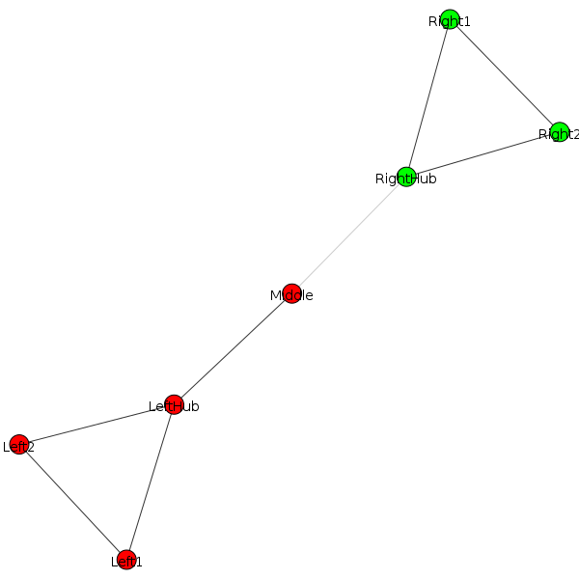

Community fast-greed
Optimal number of clusters: 2
Clustering with 7 elements and 2 clusters
[0] 0, 1, 2, 3
[1] 4, 5, 6
Membership:
[0, 0, 0, 0, 1, 1, 1]
Number of communities: 2
Modularity: 0.3671875

Louvain
Clustering with 7 elements and 2 clusters
[0] 0, 1, 2, 3
[1] 4, 5, 6
Quality: 7.79125484612
Modularity: 0.3671875

Radatools
---------
Parameters: WN erfrtrfr 5
Q = 0.367188
---
Number of elements: 7
Number of lists: 2

4: 4 5 6 7
3: 1 2 3

Results

Graph4+4
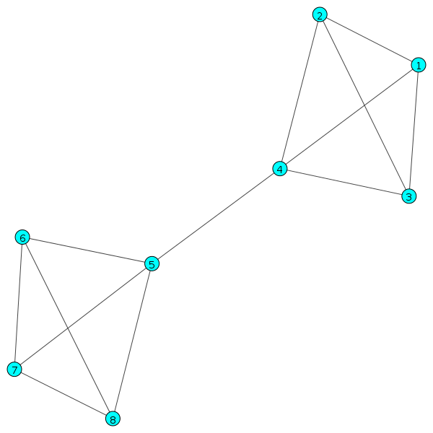

Community multilevel
Clustering with 8 elements and 2 clusters
[0] 0, 1, 2, 3
[1] 4, 5, 6, 7
Membership:
[0, 0, 0, 0, 1, 1, 1, 1]
Number of communities: 2
Modularity: 0.423076923077
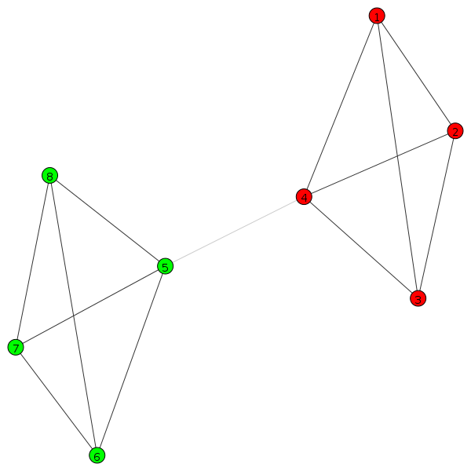

Community fast-greed
Optimal number of clusters: 2
Community:
Clustering with 8 elements and 2 clusters
[0] 0, 1, 2, 3
[1] 4, 5, 6, 7
Membership:
[0, 0, 0, 0, 1, 1, 1, 1]
Number of communities: 2
Modularity: 0.423076923077

Louvain
Clustering with 8 elements and 2 clusters
[0] 4, 5, 6, 7
[1] 0, 1, 2, 3
Quality: 18.4141236651
Modularity: 0.423076923077
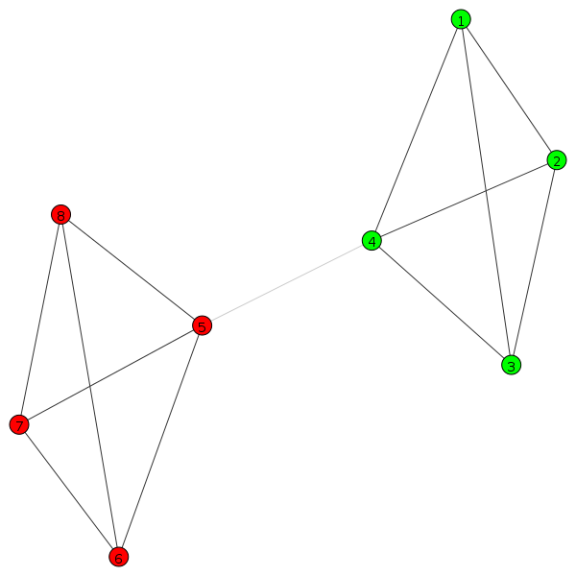

Radatools
---------
Parameters: WN erfrtrfr 5
Q = 0.442857
---
Number of elements: 8
Number of lists: 2

4: 5 6 7 8
4: 1 2 3 4

Results

Star
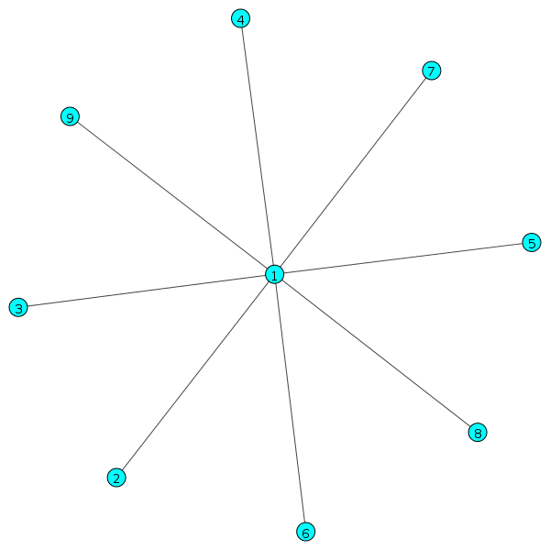

Community multilevel
Clustering with 9 elements and 1 clusters
[0] 0, 1, 2, 3, 4, 5, 6, 7, 8
Membership:
[0, 0, 0, 0, 0, 0, 0, 0, 0]
Number of communities: 1
Modularity: 0.0
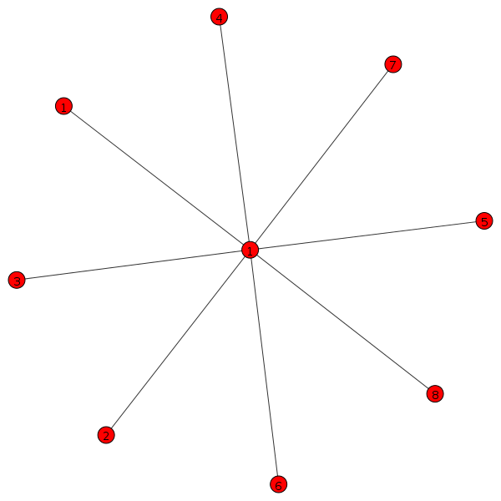

Community fast-greed
Optimal number of clusters: 1
Clustering with 9 elements and 1 clusters
[0] 0, 1, 2, 3, 4, 5, 6, 7, 8
Membership:
[0, 0, 0, 0, 0, 0, 0, 0, 0]
Number of communities: 1
Modularity: 0.0

Louvain
Clustering with 9 elements and 1 clusters
[0] 0, 1, 2, 3, 4, 5, 6, 7, 8
Quality: 0.0
Modularity: 0.0

Radatools
---------
Parameters: WN erfrtrfr 5
Q = 0.000000
---
Number of elements: 9
Number of lists: 1

9: 1 2 3 4 5 6 7 8 9

Results

